Length |  | Weight |  | Area
1000 m = 1 km |  | 1000 kg = 1 tonne |  | 10 000m² = 1 hectare
2450 m = 2⋅45 km |  | 4700 kg = 4⋅7 tonnes |  | 8000 m² = 0⋅8 hectares
5800 m = 5⋅8 km |  | 6050 kg = 6⋅05 t |  | 15600 m² = 1⋅56 h

1. One of the main athletic events in the Olympics is the 1500 m. How far is this in km?

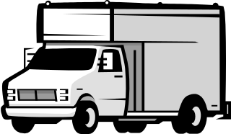
2. A large van weighs 1100 kg.
What is its weight in tonnes?


3. A football pitch has an area of 9000 square metres.
What is its area in hectares?

4. What is 2∙25 km expressed in metres?



5. The maximum weight a lift can carry is 1∙75 t.
How many kg can the lift carry?

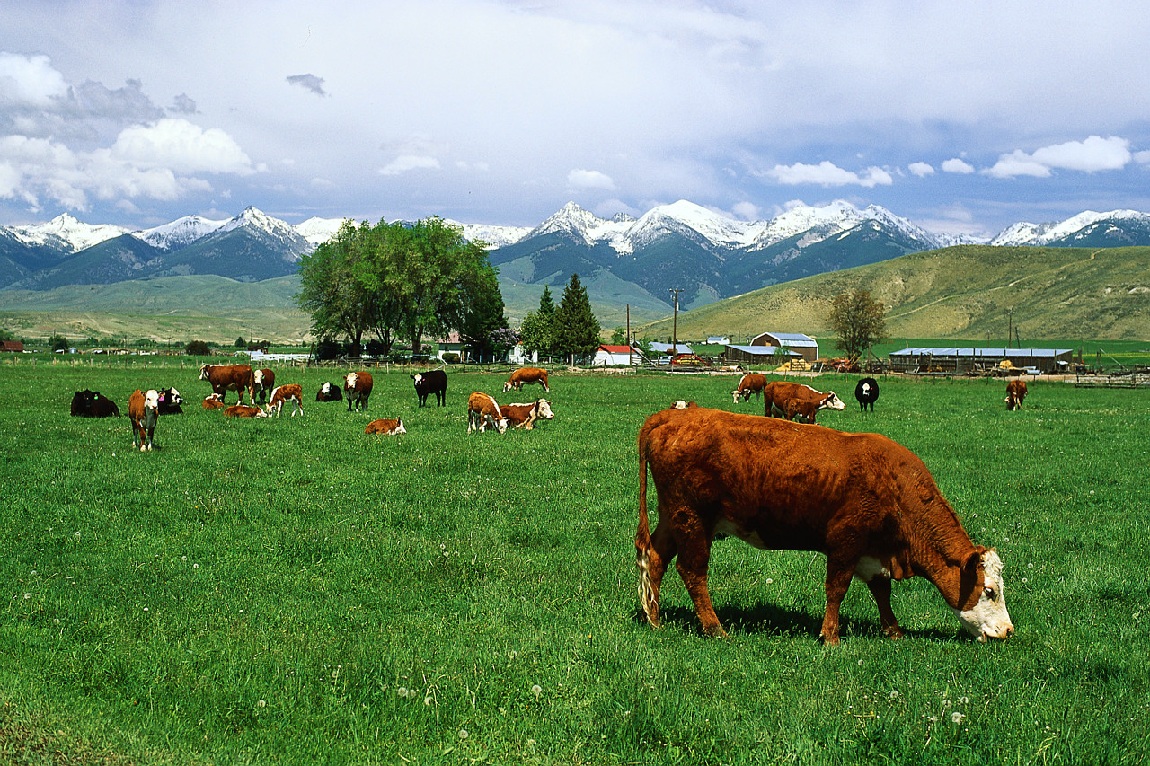

6. The area of a field is 1∙7 h.
What is its area in square metres?

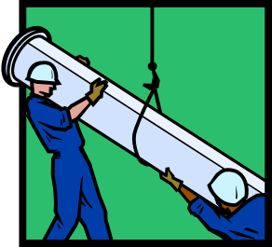
7. A gas pipeline is being laid with 20 m
lengths of pipe joined together.
The engineer expects to use 70 pipes
altogether. How long is the pipeline in km?

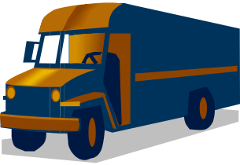
8. A lorry is carrying 30 boxes, and each box weighs 80 kg.
What total weight is the lorry carrying in tonnes?

9. A field measures 200 m × 150 m. What is its area in hectares?

10. 10 boxes weigh 1⋅75 tonnes altogether. What is the average weight of each box in kg?

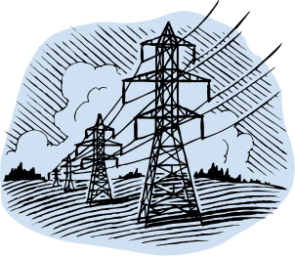
11. 11 electricity pylons (10 lengths of cable) cover a
total distance of 2⋅8 km. What is the average
distance between each pylon?

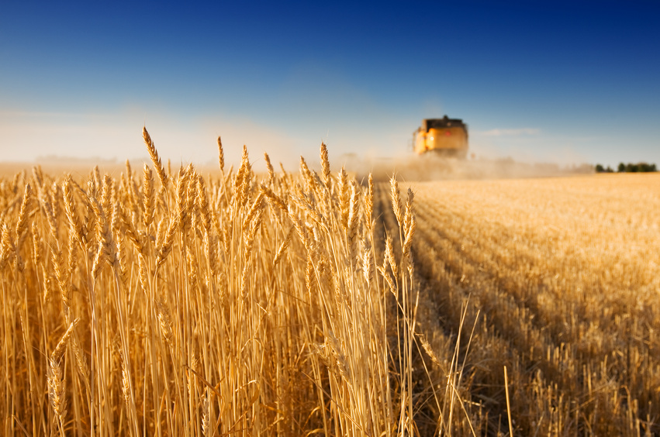
12. A farmer intends to divide his large 3⋅5 hectare
field into 5 smaller fields.
What will the average size of each field be in
square metres?

13. What will the total weight of 40 buckets of cement if each bucket weighs 150 kg? Give your answer in tonnes

14. A field is 120 m long and 80 m wide. What is its area in hectares?

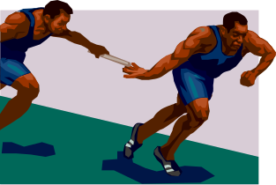
15. How far is the 4 × 400 m relay race in km?

16. The total weight of 100 people was measured to be 6⋅25 tonnes. What is the average weight in kg per person?

17. A lorry can carry a maximum load of 5⋅5 tonnes. How many boxes can it safely carry if each box weighs 20 kg?

18. A lift has a notice in it saying
No more than 20 persons at an average weight of 65 kg per person.

What is the maximum weight in tonnes the lift should carry?

